TASK Set Up A Cover Page
Title or Task: | Basic Essay Submission & Cover Page

Description:
Files Required | None
Suitable for Classes: | All
Area: | Technology & Enterprise
Teacher: | Mr Peter Faulks

Timeline

Date Due:

Task Brief:
Outcomes: | Students understand the basics of submitting essays


Items highlighted in yellow are tasks for you to complete
Items in Blue are help tips

Set up a cover page for presentation of a school or college task essay or report.

First understand wether you are submitting an Essay or a Report

An Essay requires: Certain content such as Introduction, Body and Conclusion along with references

A Report Requires: Objectivity, Restraint, Correctness, Conciseness and Clearness along with references

Included here is samples of a cover page for each. A cover page presents your work in a professional manner it is usually worth a percentage of your mark for correctness and appearance.

ALWAYS CHECK YOUR SPELLING BEFORE SUBMITTING

A Cover page should be one page at the beginning of your submission with or without borders and include:

Name: Your name

Title: Applied Information Technology

Task Number: i.e. Task 5

Task Title: Name presented i.e. Cover Page

Date due: Enter date (Can also include Date Submitted:)

Graphic: Picture of you or appropriate clip art for topic being covered

Declaration: Non plagiarised work

“I declare that this is my own work and has not been submitted, in part or in whole, for any other unit”

__________________________ Signed

If using this document you will need to delete the notes and sections that ARE NOT RELEVANT you may also need to amend the references.

Table of Contents

Different First Page 3
Page spacing 4
Table of Contents (Insert, Index and Tables) 5
Cover page for an Essay 5
Cover page for a report 8
Journal - How to produce a report 10
REPORT WRITING 10
Form Of Report 11
INFORMATION REPORT/FACTUAL DESCRIPTION 12
How to Reference 14
Online Document including Web Page 14
Types of Bibliography 14
Other forms of Referencing 15
Journal Article 16
Books 17
Electronic Sources 18
Non-Printed Media 19
Archival and Documentary Resources 19
Textual Footnotes 20
Online Resources 20
For further reference, see: 20

Different First Page

For the front (cover) page this should be set up without header or footer
From File Page Set Up Click on Layout tick different first page
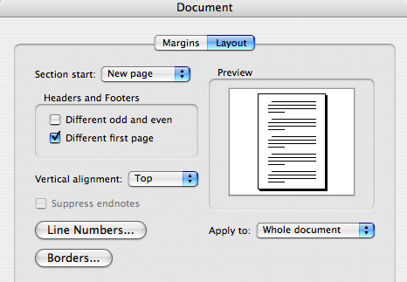
- On the header put your name class and subject or title
Ima Goodkid Y11 Digital Media How To Write A Report

- On the footer type Page ? (insert) of ?? (insert no pages)

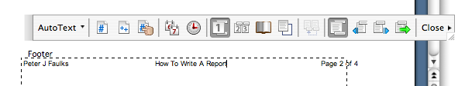

Page spacing
- Your report typed as 1.5 line spacing
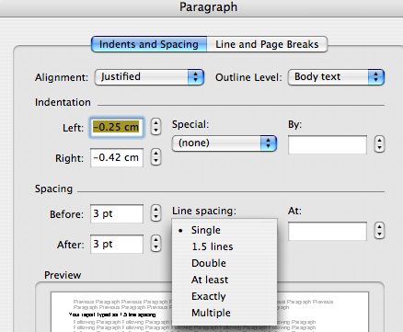

Page set up should be as follows: Left Margin 3 cm Right Margin 2 or 3 cm you may also mirror margins if submitting a stapled document.
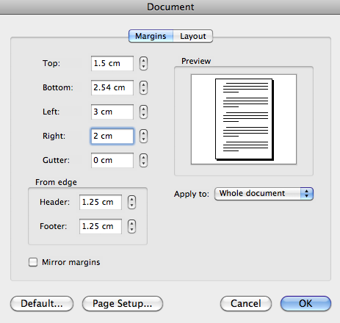

Table of Contents (Insert, Index and Tables)
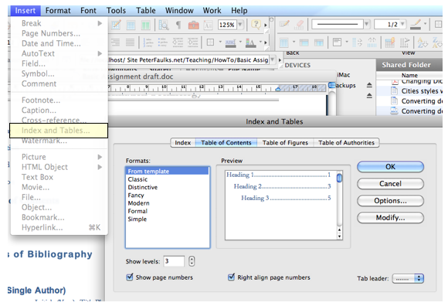

To create a table of contents:
- Place the insertion point where you want to insert the table of contents.
- On the Insert menu, click Index and Tables, and then click the Table of Contents tab.
- Select the format and other options. To change the content of the table of contents, click Options. To change the format styles, click Modify. When you’re satisfied with the preview you see, click OK.
Tip: Automate the creation of your table of contents by using built-in heading styles (Heading 1 through Heading 9) in your document.

COVER PAGE Sample follows - MODIFY TO SUIT ADD Images to enhance

Cover page for an Essay

Do NOT submit Essays or Reports in A4 Sleeves your document should be stapled three staples left side and be an open document, however you may submit an essay in a document folder but do NOT use sleeved folders.

ALWAYS make a back up of you work BEFORE submitting it to print.

I suggest you purchase a Flash Drive specifically for school work of a size that should carry all you work. On the flash drive create a folder with your name. (You would be amazed how many Flash Drives are left in Computer Rooms)

Unit Title (Class)
Cover Page for an Essay

Teacher - Unit Controller:
Peter J Faulks

ASSIGNMENT TITLE

Picture of yourself

Due: Friday 15th May, 2015

Length: 1500 words

Topic: Online Tasks

Worth: 20%

Insert images to enhance cover page

“I declare that this is my own work and has not been submitted, in part or in whole, for any other unit”

__________________________ Signed

NAME: Peter J Faulks

STUDENT ID:

MARK/GRADE:

Email: peterfaulks@westnet.com.au

Cover page for a report

Do NOT submit Essays or Reports in A4 Sleeves your document should be stapled three staples left side and be an open document, however you may submit an essay in a document folder but do NOT use sleeved folders.

ALWAYS make a back up of you work BEFORE submitting it to print.

I suggest you purchase a Flash Drive specifically for school work of a size that should carry all you work. On the flash drive create a folder with your name. (You would be amazed how many Flash Drives are left in Computer Rooms)

Unit Title (Class)
Cover Page for a Report

Teacher - Unit Controller:
Peter J Faulks

REPORT TITLE

Picture of yourself

Due: Friday 22nd May, 2015

Length: 1500 words

Purpose: To compare writing skills

Worth: 20%

Insert images to enhance cover page

“I declare that this is my own work and has not been submitted, in part or in whole, for any other unit”

__________________________ Signed

NAME: Peter J Faulks

STUDENT ID:

MARK/GRADE:

Email: peterfaulks@westnet.com.au

Journal - How to produce a report

Teacher: Mr Faulks

REPORT WRITING

General Characteristics
The aim in report writing is to present a businesslike message in as clear a form as possible. Emphasis is placed on correctness, conciseness and clarity.

Objectivity
The first requirement of every report is that it be written without personal prejudice. A report must be approached with a completely open mind, materials assembled in carefully organised form and recommendations made on the basis of findings. Even the language of a report should be impersonal.

Restraint
The report should contain no exaggerations and few superlatives. Present the facts and guard the conclusions with expressions like ‘it seems likely’ or ‘evidence seems to indicate.’

Directness
Come to the point at once. Use no unnecessary details. Each paragraph should begin with a topic sentence that will show clearly the point to be discussed in the paragraph.

Correctness
In a serious business communication, errors in grammar, spelling sentence structure and punctuation are inexcusable and will make a very poor impression. Information and data must be collected and compiled with thoroughness and exactness.

Conciseness
Include no unnecessary details or words.

Clearness
The first requirement for clarity is a logical plan. If related ideas are not placed together and arranged in order, the report will be unsuccessful. Choice of language is important. Consider the background of the people for whom the report is intended and choose words that will be understandable to them. Avoid abstract language and jargon.

Form Of Report
A formal report should have the following points:
- Title page
- Table of contents
- Summary
- Report
- Diagrams, charts

Very formal reports also include a letter of transmittal and a bibliography.

Charts and diagrams should be numbered and given a title. They must always be explained in the text of the report.

Use double spacing and margins of 2cm and 17cm.

Other Features: Can contain photographs, diagrams, and maps...

INFORMATION REPORT/FACTUAL DESCRIPTION

Purpose: To classify and describe.

Focus: Animate or inanimate things (rather than a sequence).

Framework

Classification/  Generalisation/  Definition | Introduces the topic.
Description | ┐  │  │  │  │
 | │
Description | │  │  │  │  │  │ Features described
 | │ in order of appearance.
Description | │ One paragraph per idea.  │  │  │  │  │
 | │
Description | │  │  │  │  ┘

Language Feature | Commonly Used | Avoid Using
Technical vocabulary | - Subject specific vocabulary  - Words that convey meaning precisely  e.g. ‘Contour lines are lines that join places of equal height above sea level.’ | - Avoid general imprecise, unnecessary vocabulary or slang.  e.g. ‘Well, squiggly lines on maps connect up places of the same height.’
Passive forms of verbs  sometimes used | - The passive verb (the subject is acted upon)  e.g. ‘The seeds were planted.’  ‘The streets were lined.’ | - Avoid Verbs in the active form  e.g. ‘The student planted the seeds.’  ‘Crowds lined the streets.’
Impersonal objective  language | - The third person objective (i.e. write they, she, he, it without revealing your thoughts or feelings)  e.g. ‘The prime minister was  questioned.’  - objective, precise description  e.g. ‘The male rat was dissected.’ | - avoid the first person (I or me  e.g. ‘I nervously asked the power-  full prime minister some  questions.’  - avoid emotive words that convey opinion  e.g. ‘The dirty, great rat was slit up the guts.’
Timeless present,  present or past tense  depending on subject  matter | - the timeless present tense (happened yesterday, today and tomorrow)  e.g. ‘The earth rotates on its axis.’  OR  - the past tense e.g. ‘The Ancient Egyptians  worshipped the Nile.’  - the simple present | - avoid an inappropriate mixture of tenses.  e.g. ‘Many religions are practised in Japan. Around 87 million people were Buddhists, about 89 million follow the Shinto religion and nearly a million became Christians.’

How to Reference

Types of Bibliography
Peter J Faulks is author of a 300 page book and several booklets and manuals…
The easy way is to copy a reference that suits your source and change it to suit your source information.
i.e. copy this below for a book then change the details

Bellito, Christopher M., (2008) “101 Questions & Answers on Popes and the Papacy”, New York, Papac, Paulist Press.

Or
Faulks, Peter J., (1997) “The Essential Coaching Handbook”, Perth, PIP Multimedia.

Online Document including Web Page
Author/editor surname, Initial. (Year) Title [online].Edition. Place of publication, Publisher. Available from: URL [Accessed date] i.e.

Faulks, P. (1997) The Essential Coaching Handbook: Essentialcoachinghandbook Web Site.[online]. 3rd edition. Perth, PIP Multimedia. Available from: http://www.essentialcoachinghandbook.net/
[Accessed 4th July 2001].

Types of Bibliography

Book (Single Author)
This is how I do it : (Baxter etc… not in bold text though) - you can change it to how you think it should read!

Author Surname, Initial. (Year). Title. Place of Publication: Publisher.

Bellito, Christopher M., (2008) “101 Questions & Answers on Popes and the Papacy”, New York, Papac, Paulist Press.

You don’t need to put the title in inverted commas – I do though…

Baxter, C. (1997). Race equality in health care and education. Philadelphia: Ballière Tindall.

Book (Multiple Author) (Standard reference type)
Author Surname, Initial and Author Surname, Initial. (Year). Title. Place of Publication: Publisher.

Burns, Nancy and Grove, Susan K. (1997) The practice of nursing research: conduct, critique & utilization. 3rd edition. London, Saunders.

Magazine or Newspaper Article
Author Surname, Initial. (Date). Title. Place of Publication, Page Numbers.

Greenberg, G. (2001, August 13). As good as dead: Is there really such a thing as brain death? New Yorker, 36-41.
Online Document including Web Page
Author/editor surname, Initial. (Year) Title [online].Edition. Place of publication, Publisher. Available from: URL [Accessed date]

Marieb.E. (2000) Essentials of Human anatomy and Physiology: AWL Companion Web Site.[online]. 6th edition. San Francisco, Benjamin Cummings. Available from: http://occ.awlonline.com/bookbind/pubbooks/marieb-essentials/
[Accessed 4th July 2001].

Other forms of Referencing

Book (Single Author)
Author Surname, Initial. (Year). Title. Place of Publication: Publisher.

Baxter, C. (1997). Race equality in health care and education. Philadelphia: Ballière Tindall.

Book (Multiple Author)
Author Surname, Initial and Author Surname, Initial. (Year). Title. Place of Publication: Publisher.
Burns, Nancy and Grove, Susan K. (1997) The practice of nursing research: conduct, critique & utilization. 3rd edition. London, Saunders.

Magazine or Newspaper Article
Author Surname, Initial. (Date). Title. Place of Publication, Page Numbers.
Greenberg, G. (2001, August 13). As good as dead: Is there really such a thing as brain death? New Yorker, 36-41.

Online Document including Web Page
Author/editor surname, Initial. (Year) Title [online].Edition. Place of publication, Publisher. Available from: URL [Accessed date]
Marieb.E. (2000) Essentials of Human anatomy and Physiology: AWL Companion Web Site.[online]. 6th edition. San Francisco, Benjamin Cummings. Available from: http://occ.awlonline.com/bookbind/pubbooks/marieb-essentials/
[Accessed 4th July 2001].

The Reference Section
The last section outlined how to cite or reference sources within the text. This section shows how to complete the reference section at the end of the essay. The reference section is the list of all the sources cited or referenced in the essay,and only those that were referenced or cited in the essay. The list is arranged alphabetically by the first author's surname. There is a format for listing different types of sources such as books, journal articles and web sources. These are set by the APA and there are numerous sources on the Web that outline the guidelines, for example Nuts and Bolts of College Writing which describes the different formats and also gives more advice on referencing within the essay text. In order to give you some idea how to format the most common sources, the APA format for each one is given below (note: these are taken from the Report Writing Guide but copied here to save download time).

Journal Article
When listing a journal article, you must give the name of the author(s), the year it was published, the title of the actual journal article, then in italics (or underlined) the name of the journal and volume number, and lastly the pages the articles is on. An example clarifies this:
Tudge, J.R.H.,¹ (1989)². When collaboration leads to regression: some negative consequences of socio-cognitive conflict³.European Journal Of Social Psychology⁴ 19,⁵123-138⁶
1. The author(s) name(s)
2. The year of publication
3. The title of the article
4. The journal's name (note italics)
5. The volume number of the Journal (again note italics)
6. The articles page numbers
If there is more that one author, merely give the authors' names in the order they are on the article:
Tudge, J.R.H.,and Winterhoff, P.A.(1989) etc...
Or for more than two authors:
Tudge, J.R.H., Winterhoff, P.A. and Hogan, D.M.(1996) etc..

References layout samples…

Barraclough, Geoffrey, (1968) “The Medieval Papacy”, Thames & Hudson, Norwich.

Bellito, Christopher M., (2008) “101 Questions & Answers on Popes and the Papacy”, New York, Papac, Paulist Press.

Bliss Frederick, (2008) “Anglicans in Rome A History”, Canterbury Press, London.

Libreria Editrice Vaticana (2005) “Compendium of the Catechism of The Catholic Church”, St Pauls Publications, McPhersons Printing Group, Sydney

Norman, Edward, (1985) “Roman Catholicism in England”, Oxford University Press, Oxford.

Seale Mark, (2005) “Liturgy Made Simple”, The Liturgical Press, Collegville, Minnesota

Quinn, John R, (199) “The Reform of the Papacy, The costly call to Christian unity Crossroad”, Publishing House, New York, 1999, p45

Books
The format for books is a little different. The author(s) name(s) come first, then in italics the title of the Book, then where the book was published, and who it was published by:
Piaget, J.¹ (1928)². Judgement and reasoning in the child³.London⁴:Routledge and Kegan Paul⁵.
1. The Author(s) name(s)
2. The year of publication
3. The title of the book
4. Where the book was published
5. The publishers
i.e.
Bellito, Christopher M., (2008) “101 Questions & Answers on Popes and the Papacy”, New York, Papac, Paulist Press.

If the book you are listing is an edited book, then you merely put the editors name where the authors' names are normally put, and put (Eds) before the year of publication. If there is more than one author or editor then follow the format for authors outlined for journal articles.

Chapters in an Edited Book
The format is similar to the book format; first the names of the authors of the chapter, the title of the chapter, the name of the editors of the whole book, the title of the Book (in italics),and finally the place of publication and the publisher:
Glachan, M., and Light,P.¹(1982)²Peer interaction and learning³. In G. Butterworth and P. Light (Eds) ⁴ Social Cognition⁵ Brighton: Harvester.⁶
1. The authors of the chapter
2. The year of publication
3. The title of the chapter
4. The editors of the book the chapter was in, (note the initials come before the surname)
5. The title of the book
6. The place of publication and publisher

Electronic Sources
Electronic sources refer to sources that have been found or retrieved through computer. These can be CD-Roms, telnet sites, or Web pages. The format for most types of electronic source can be found at the APA's own site. The example provided here is of a web-page which is the most common used type of electronic source. It is important to note that the APA make a distinction between citing a whole web site and citing individual pages within a web site. If you cite a whole web site then you merely need to give the URL (the web address) within the text and no corresponding entry in the reference section is needed.
If you are citing a page within a site then a entry within the reference section is needed:
Memory and dementia (1998)¹. London: The Royal College of Psychiatrists². Retrieved January 25, 1996³, from the World Wide Web: http://www.rcpsych.ac.uk/public/help/memory/memory.htm⁴
1. The title of the page and date of publication
2. What organisation was responsible for the page
3. When you looked at the page
4. The URL or web address
If the page has an obvious author, his/her name goes before the title in the manner of a Journal Article. If you have any problems with reference formatting then check out the websites included on the Links page within the Report Writing Guide. The next page outlines a few of the errors made by students in referencing a text.

http://www.psy.gla.ac.uk/~paul/tutorials/essay/essrefer.htm

How to insert Footnotes
Copy the reference first then insert your footnote – paste in the reference after the small number at the bottom of your page.

Printed Resources
How to footnote a book:
¹ Ronald Takaki, Iron Cages: Race and Culture in 19th-Century America (New York: Oxford University Press, 1990), p. 113.
or:
² Ronald Takaki, Iron Cages: Race and Culture in 19th-Century America (New York: Oxford University Press, 1990), p. 113.
When the book is edited:
³ Edward Chiera, They Wrote on Clay, ed. George C. Cameron (Chicago: University of Chicago Press, 1938), p. 42.
How to footnote an essay in a journal:
⁴ Samuel M. Thompson, "The Authority of Law," Ethics 75 (October 1964): 16-24.
How to footnote an article in a newspaper:
⁵ "Amazing Amazon Region," New York Times, 12 January 1969, sec. 4, p. E11.

Non-Printed Media
How to footnote a radio or television program:
⁶ TVNZ, "The Amazing Mollusc," 17 April 1972.
How to footnote a film:
⁷ Lee Tamahori, Director, Once Were Warriors, 1995.
How to footnote a recording (in this case, a song called "Blood Red River," on an album called The Legendary Peg Leg Howell:
⁸ Peg Leg Howell, "Blood Red River," The Legendary Peg Leg Howell, 1943, Testament T-2204.
How to footnote a work of art (in this case, a painting):
⁹ Larry Calcagno, Landscape, 1970.

Archival and Documentary Resources
How to footnote a document in an archive:
¹⁰ Gen. Joseph C. Castner, "Report to the War Department, 17 January 1927," Modern Military Records Division, Record Group 94, National Archives, Washington, D.C.
¹¹ Stanley K. Hornbeck, Memorandum on Clarence Gauss, 8 May 1942, Hornbeck Papers, File "Gauss," Hoover Library, Stanford, California.
How to footnote an entire collection in an archive:
¹² Washington, D.C., National Archives, Modern Military Records Division, Record Group 94.
How to footnote a letter written to you:
¹³ John Blank, personal letter, 12 February 1994.
How to footnote a letter that is not in an archive:
¹⁴ Alan Cranston, California State Controller, to Maurice Sexton, Sacramento, 22 October 1962, Personal Files of Maurice Sexton, Modesto, California.
How to footnote a document not in an archive:
¹⁵ Morristown (Kansas) Orphan's Home, Minutes of Meetings of the Board of Managers, Meeting of 6 May 1930.
¹⁶ Sidney E. Mead, "Some Eternal Greatness," sermon preached at the Rockefeller Chapel, University of Chicago, 31 July 1960.
How to footnote a dissertation:
¹⁷ O. C. Phillips, Jr., "The Influence of Ovid on Lucan's Bellum civile" (Ph.D. dissertation, University of Chicago, 1962), p. 14.
How to footnote an interview:
¹⁸ A. A. Wyler, interview held during meeting of the American Astronomical Society, Pasadena, California, June 1964.

Textual Footnotes
How to add a textual footnote (explaining something in the text):
¹⁹ Detailed evidence of the great increase in the array of goods and services bought as income increases is shown in S. J. Prais and H. S. Houthaker, The Analysis of Family Budgets (Cambridge: Cambridge University Press, 1955), table 5, p. 52.
²⁰ Ernst Cassirer takes important notice of this in Language and Myth (pp. 59-62), and offers a searching analysis of man's regard for things on which his power of inspirited action may crucially depend. [Since the work has already been cited in full form, page reference only is required.]
²¹ In 1962 the premium income received by all voluntary health insurance organizations in the United States was $9.3 billion, while the benefits paid out were $7.1 billion. Health Insurance Institute, Source Book of Health Insurance Data (New York: The Institute, 1963), pp. 36, 46.
²² Professor D. T. Suzuki brings this out with great clarity in his discussion of "Stopping" and "no-mindedness"; see, e.g., his chapter entitled "Swordsmanship" in Zen Buddhism and Its Influence on Japanese Culture (Kyoto: Eastern Buddhist Society, 1938).

Online Resources
How to footnote a Web page:
²³ Jim Zwick, Anti-Imperialism in the United States, 1898-1935, http://www.rochester.ican.net/~fjzwick/ail98-35.html (May 1997).

For further reference, see:
C. Lavender's "How to Cite, Bibliography: Using the Chicago Manual of Style," http://www.library.csi.cuny.edu/dept/history/lavender/footnote.html.
The Chicago Manual of Style or Kate L. Turabian, A Manual for Writers of Term Papers, Theses, and Dissertations.
The Sarah Bird Askew Library of the William Paterson College of New Jersey's "Guide for Citing Electronic Information" (www.wilpaterson.edu/wpcpages/library/citing.htm), a version of Li and Crane's "Bibliographic Formats for Citing Electronic Information" (www.uvm.edu/~ncrane/estyles/)
Maurice Crouse's "Citing Electronic Information in History Papers" (www.people.memphis.edu/~mcrouse/elcite.html)
Janice R. Walker's "MLA-Style Citations of Electronic Sources" (www.cas.usf.edu/english/walker/mla.html), endorsed by the Alliance for Computers & Writing
Mark Wainwright's "Citation style for Internet sources" (http://www.cl.cam.ac.uk/users/maw13/citation.html)

http://www.library.csi.cuny.edu/dept/history/lavender/footnote.html

